HTML Meta Element

📖 Definition
# Source: AI Source: Provided by: [Data Path: Persons Table -> ID Column: 1, Name_En Column: Motasem Essam] -> From: [ChatGPT] on [5/6/2026]
The <meta> element provides extra information (metadata) about an HTML document.
This information is not shown on the page, but is used by browsers, search engines, and devices.

⚙️ Common Uses of <meta> Element

🌐 1. Character Encoding (UTF-8)
# Source: AI Source: Provided by: [Data Path: Persons Table -> ID Column: 1, Name_En Column: Motasem Essam] -> From: [ChatGPT] on [5/6/2026]
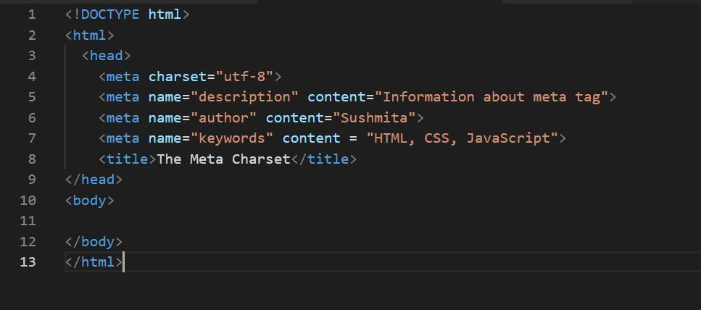
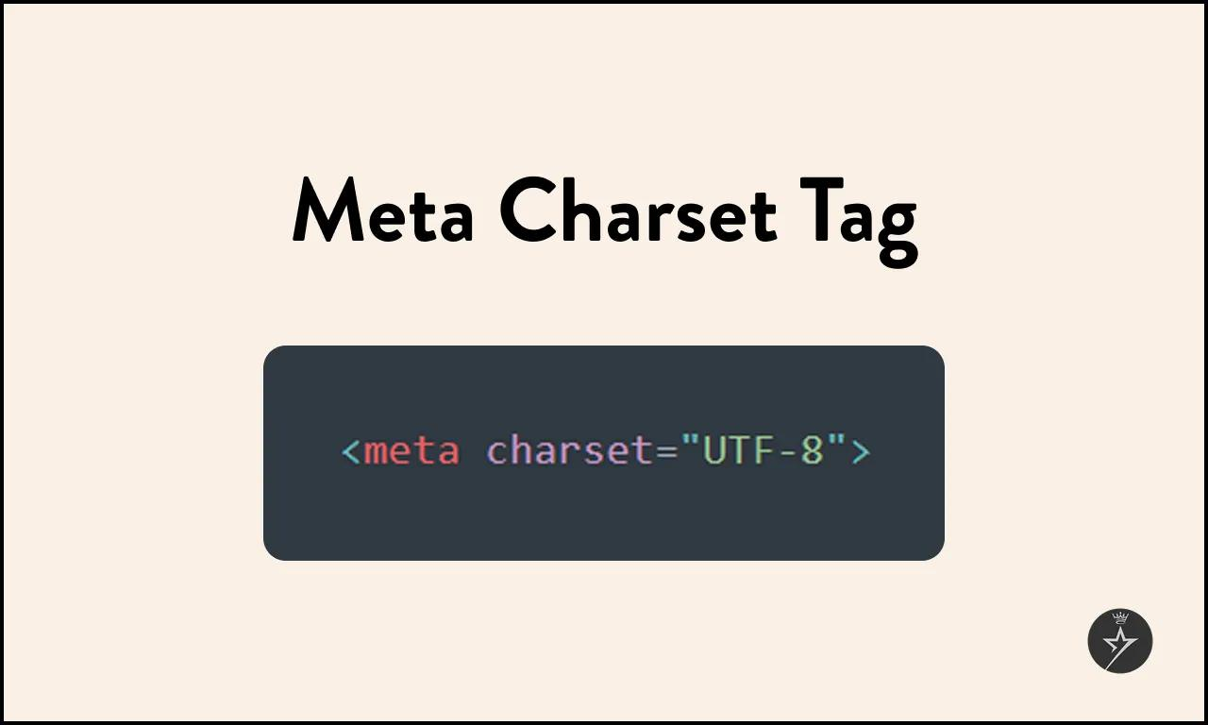
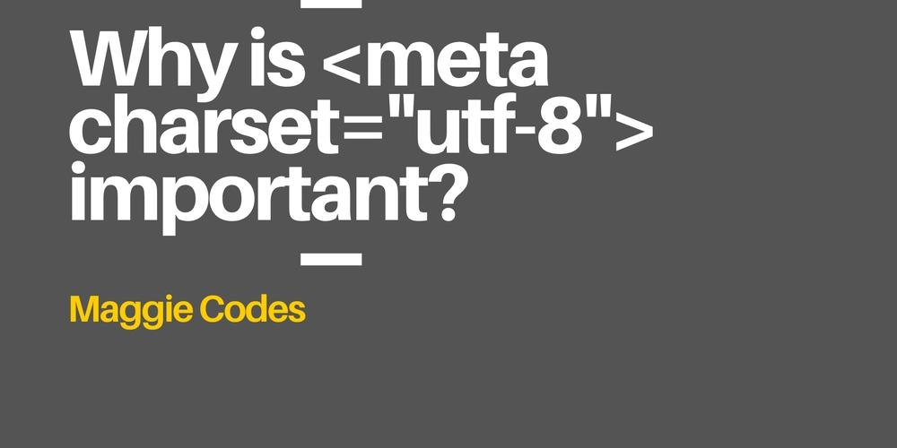
📖 Description
Defines how text is displayed in the browser (supports all languages).
💻 Example:
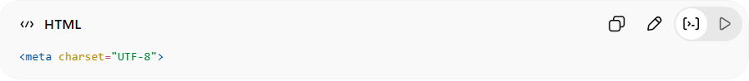
<meta charset="UTF-8">
👉 Ensures correct display of letters and symbols

📱 2. Responsive Design (Viewport)
# Source: AI Source: Provided by: [Data Path: Persons Table -> ID Column: 1, Name_En Column: Motasem Essam] -> From: [ChatGPT] on [5/6/2026]
📖 Description
Makes the website fit properly on mobile, tablet, and desktop screens.
💻 Example:
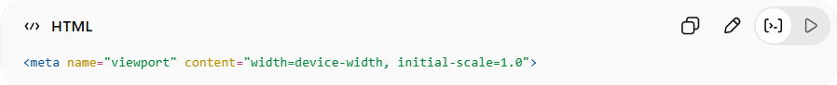
<meta name="viewport" content="width=device-width, initial-scale=1.0">
👉 Makes websites mobile-friendly

🔍 3. SEO Description
# Source: AI Source: Provided by: [Data Path: Persons Table -> ID Column: 1, Name_En Column: Motasem Essam] -> From: [ChatGPT] on [5/6/2026]
📖 Description
Provides a short description of the webpage for search engines.
💻 Example:
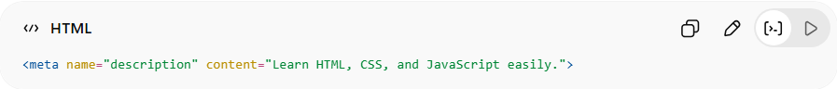
<meta name="description" content="Learn HTML, CSS, and JavaScript easily.">
👉 Helps Google understand your page

🔑 4. Keywords (Old SEO use)
# Source: AI Source: Provided by: [Data Path: Persons Table -> ID Column: 1, Name_En Column: Motasem Essam] -> From: [ChatGPT] on [5/6/2026]
📖 Description
Defines keywords related to the page (less used today).
💻 Example:
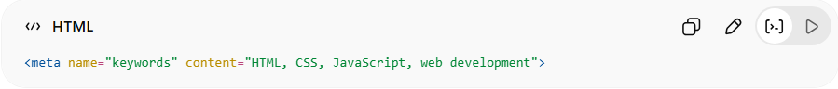
<meta name="keywords" content="HTML, CSS, JavaScript, web development">

👤 5. Author Information
# Source: AI Source: Provided by: [Data Path: Persons Table -> ID Column: 1, Name_En Column: Motasem Essam] -> From: [ChatGPT] on [5/6/2026]
📖 Description
Defines the author of the webpage.
💻 Example:
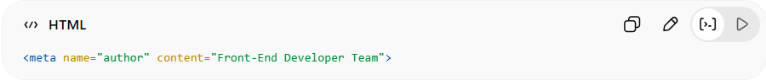
<meta name="author" content="Motasem Essam">

🔄 6. Page Refresh / Redirect
# Source: AI Source: Provided by: [Data Path: Persons Table -> ID Column: 1, Name_En Column: Motasem Essam] -> From: [ChatGPT] on [5/6/2026]
📖 Description
Automatically refreshes or redirects the page.
💻 Example:
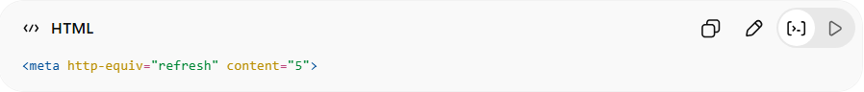
<meta http-equiv="refresh" content="5">
👉 Refreshes page every 5 seconds

⚙️ Where <meta> is placed
# Source: AI Source: Provided by: [Data Path: Persons Table -> ID Column: 1, Name_En Column: Motasem Essam] -> From: [ChatGPT] on [5/6/2026]
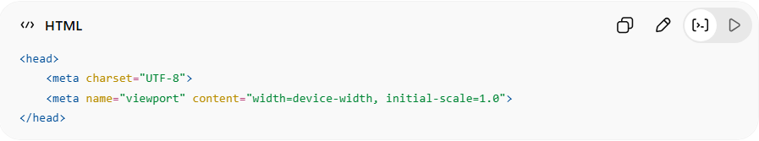
<head>
<meta charset="UTF-8">
<meta name="viewport" content="width=device-width, initial-scale=1.0">
</head>
👉 Always inside <head>

🚀 In short:
# Source: AI Source: Provided by: [Data Path: Persons Table -> ID Column: 1, Name_En Column: Motasem Essam] -> From: [ChatGPT] on [5/6/2026]
<meta> = an HTML element that provides hidden information about the webpage for browsers and search engines.

